Tourism Grant Program Guidelines
APPLICATION PACKET

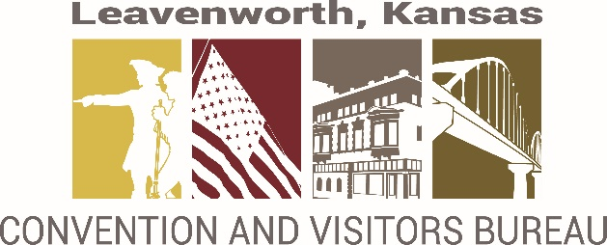

ABOUT Leavenworth CVB

Our Mission: The mission of the Leavenworth Convention and Visitors Bureau is to attract visitors, tour groups, and meeting and convention business to the Leavenworth community.
Our Focus: To increase occupancy at Leavenworth hotels and increase attendance at Leavenworth attractions.
ABOUT THE PROGRAM

The CVB Tourism Marketing Grant Program was established to enhance the economic impact of tourism in our community. The grant is a reimbursement grant and not designed to cover the entire cost of a project. This grant is designed to assist an organization with their event or marketing program. Priority will be given to distinctive and creative projects or events that support the goals and mission of the CVB. This grant leverages the CVB’s resources and extends the marketing reach for the City of Leavenworth.

GOALS FOR PROGRAM

These funds should support marketing and events that:

  - Demonstrate a measurable community or economic benefit,

  - Enhance Leavenworth’s character and reputation for tourist activities;

  - Attract new events and/or strengthen existing events marketing abilities;

  - Generate additional transient guest tax and sales tax for the community.

POLICIES AND PROCEDURES

Tourism Grants are available to any Leavenworth based organization marketing their project /event to attract out-of-town visitors to Leavenworth. Qualifying applications must meet the following criteria:

- Events/Programs that encourage overnight lodging and increase attraction attendance will be given preference.
- A detailed description of the promotional materials design work and advertisement examples must be included.
- Maximum grant award shall not exceed $5,000. Depending on the number of applications, Leavenworth CVB may only partially fund some requests. Organizations are limited to one grant per award cycle and per project. Submitting a grant application does not guarantee award of funding.

APPLICATION PROCESS

The deadline for the first granting cycle is February 1st and the second, August 1st. If the 1st falls on a weekend then the following Monday becomes the deadline. The application must be completed in full, including a proposed budget, detailed expenses & revenues, and signed by appropriate person in charge. If more space is needed, please attach additional pages or documents to the application. All applications must be mailed or delivered to:
Kristi Lee, Director of Tourism
Leavenworth Convention and Visitor’s Bureau 100 N. 5th St. Leavenworth, KS 66048 klee@firstcity.org

The Convention and Visitors Bureau will appoint a committee to review applications and determine eligibility. All awards are subject to scoring criteria and available funding. Notifications will be made via email or letter on or before March 1st and September 1st.
The Convention and Visitors Bureau approves the grant funding only – it is the responsibility of the awardee to ensure all other City approvals/permits are obtained in advance.

PROJECT DEVELOPMENT

The CVB must be notified in writing as soon as possible if the applicant does not plan to use their approved funds. Grant funds must be used for the project for which they have applied for in their application.

All public notices and promotional materials for your project or event must acknowledge the sponsorship of the Leavenworth Convention & Visitors Bureau and include the CVB logo.

The recipient of the grant is responsible for any and all liability issues evolving from the activities of this project.

PROJECT COMPLETION REPORT

Projects must be completed within one year. A mandatory follow-up report is due within 30 days after completion of your project. Funds will be dispersed after acceptance of the report.

The report must include a summary of the event or marketing success, all data captured from the event and/or marketing, including visitor counts, room stays, and use of funding in overall budget.

ELIGIBLE PROJECTS FOR FUNDING
Fundable Items (including but not limited to):

- Graphic Design and/or Printing of promotional materials.
- Advertisements that market to visitors spending the night in Leavenworth.
- Brochure and Guide distribution.
- Free Hats, shirts, banners, flags, and other promotional items will be considered if they are part of the marketing plan for distribution outside of the community, and /or as part of advertising for an event or attraction prior to the event.
- Event expenses for hosting a destination event drawing attendees from outside the region and other states.
- Advertising: Print, social media, digital (web), radio, television
- Printing: Flyers, posters, billboards, pre-event signage/banners, direct mail
- Video: Publicity video to promote event or attraction
- Website: Event/program/attraction website design
- Other tourism related projects/activities/call with questions
Non-fundable items (including but not limited to):

- Marketing of local community events that promote mostly to local citizens and are attended predominantly by local citizens
- Organizations or projects that are affiliated with a political party, lobbying, or advocacy related activities
- General operating expenses
- Membership fees in other organizations
- Salaries and Wages
- Honorariums
- Items/swag for resale
- Scholarships or cash awards
- Venue rental
- Solicitation literature
- Building repairs or upgrades, brick and mortar projects
- Private parties, functions and events not open to the general public

QUESTIONS
- Events occurring in public spaces or right-of-way may require coordination with other organizations and/or city services. If appropriate, approval letters need to be included as part of this grant application along with City Event Permit paperwork. https://www.leavenworthks.org/cityclerk/page/permits-and-licenses
- For assistance, contact the Leavenworth CVB at 913-758-2948 or klee@firstcity.org.

Grants are discretionary and based on available funds. Final determination of fundable and non-fundable items is solely at the discretion of the CVB and City of Leavenworth.

Grant recipient shall defend, indemnify, and hold harmless the City of Leavenworth and the Leavenworth Convention and Visitors Bureau, their officers and employees from any claims, damages, liabilities, losses, government process, costs, expenses, including attorney’s fees and costs of suit, arising out of any misrepresentation misappropriation of intellectual property, violation of privacy rights, and any injury to persons or property arising out of the event. The City of Leavenworth and Leavenworth Convention & Visitors Bureau is relying upon the event organizer to make all necessary arrangements for security and safety at the event, and is not responsible to the event organizer or to any third parties for their safety.

Rev: 3/15/23
Leavenworth CVB Grant Application

Please review the Grant Guidelines before completing this form.

- Business Information

Organization Name

Project Manager Name Title

Address __City State Zip _
Telephone ( _) E-mail Address
Organization’s Web Site

Mission of the Organization and Examples of Programing or Activities

Admission/Attendance Figures for Related Event (if applicable) _ Current Marketing Plan for this Organization

- Project Information
  - Attach a copy of the Design/Project/Event
  - Project Name _ Description of the Grant Project Overview (project description with plan of fund use)

- Project Estimated Begin Date
Estimated Completion Date

Please include any other dates related to the project

Estimated project cost (include copies of professional service bids such as creative design, print, enhancements, photography, and so on, as available. (Please include information on local vendor services, if applicable.)

Include the distribution/marketing plan for your project, include the quantity of promotional pieces to be printed, distributed, and/or mailed, if applicable.

- Funding Information

The costs should be estimated as closely as possible.

Total Project Cost $

Grant Funds Requested $ Not to exceed $5,000.

Applicant Match $

What other funding sources have you applied for or considered, to support the grant project?

Will you be able to complete this project if we are unable to fund your request?

Have you or any of the applicant partners previously received a Grant from the CVB?

Yes No If yes, when:

- Required Information

Do you expect an increase in overnight stays in Leavenworth as a result of this marketing activity? What is the number of hotel rooms expected to be used?

Will this project create or sustain tourism related jobs?

Are any new partnerships being formed to support the grant activities?

What do you expect the economic impact or other benefits will be to the Leavenworth region as a result of this marketing activity? Are there other ways this project will impact the community?

How will this project be tracked? Once the project is completed, please provide a one page report to the CVB on the results and the measurement of the return on investment?

Please include any other supporting documents.

  - Current Letter(s) of Support
  - Listing of the Applicant’s Board of Directors or Organizational Structure

Mail, hand deliver, or email the original of the completed application to:

Kristi Lee, Director of Tourism
Leavenworth Convention and Visitors Bureau 100 N. 5th St. Leavenworth, KS 66048 klee@firstcity.org

- Authorized Signatures

I have read the grant guidelines and have accurately completed this application. I understand that this is a competitive grant process and that I must meet the eligibility requirements outlined in the grant guidelines in order to be considered for a grant. I acknowledge that I have the authority to submit this application.
I understand that it is a criminal violation under Kansas Law to engage in deception and knowingly make or cause to be made, directly or indirectly, a false statement in writing for the purpose of procuring transient guest tax funding assistance from government funds.
MUST BE SIGNED AND DATED

Name: Date:

About the Tourism Grant Funding
This grant is funded by the transient guest tax paid by visitors who spend the night in hotels in the city limits of Leavenworth. It is collected by the hotels and administered by the City of Leavenworth. The Convention and Visitors Bureau is a division of the City of Leavenworth.

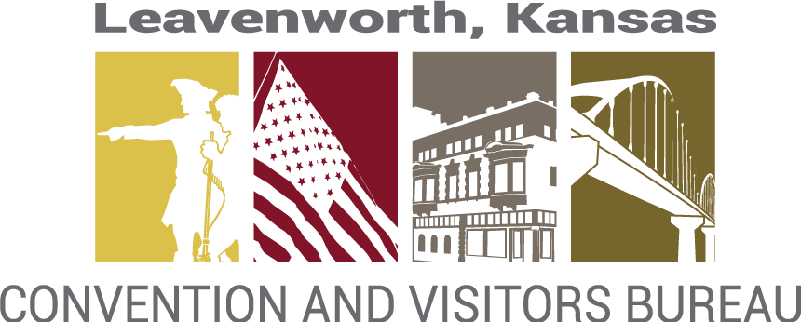

Tourism Grant Completion Report

The Completion Report must be submitted to the CVB within 30 days of project/event completion. Grant awardees must complete this form in full. Funding will occur after form review and acceptance by the CVB. Future funding awards will take into consideration the Return on Investment included on this form.
Project/Event Name

Project Location

Documentation (list attached items; such as printed materials, ad copy, event program, etc.)

Final cost of project (attach a summary along with all paid invoices or receipts)

Admission/Attendance Figures for Related Event

Number of out-of-town attendees

Number of lodging rooms used per day

Additional information

Make check payable to:
Return completed form to:
Kristi Lee, Director of Tourism
Leavenworth Convention and Visitors Bureau 100 N. 5th St. Leavenworth, KS 66048 cvb@firstcity.org ● 913-758-2948

Address: City Zip

The above completion report is an accurate representation of the project.

Authorized Signature Date

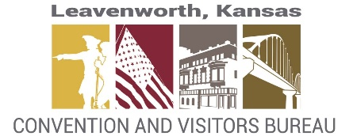
Leavenworth CVB Tourism Grant
REPORT Form summary

PROJECT/ EVENT NAME ______________________________________________________________________________

DATE APPROVED _____________________________________ AMOUNT APPROVED ____________________________

REVENUES AMOUNT

1. _____________________________________________________________ ____________________________
2. ____________________________________________________________ ____________________________
3. ____________________________________________________________ ____________________________

TOTAL ______________________
EXPENSES: copies attached

1. ____________________________________________________________ ____________________________

2. ____________________________________________________________ ____________________________

3. ____________________________________________________________ ____________________________

4. ____________________________________________________________ ____________________________
5. ____________________________________________________________ ____________________________
6. ____________________________________________________________ ____________________________

TOTAL _______________________

REVENUE OVER EXPENSES __________________________

ATTENDANCE: _________________________________
NUMBER OF ROOM NIGHTS:______________________

SIGNATURE:______________________________________________________ DATE:_________________________

